Title of the Extended Abstract
for the Poster for Türkiye Hydrogen Summit 2026
First A. Author^{1,2,*}, Second B. Author², and Third C. Author³
¹School of Brilliant Engineering, Best University, City/Town, Country
²School of Excellent Engineering, Excellent University, City/Town, Country
³ The Excellence Ltd., City/Town, Country
*Contact: First.Author@uni.edu, phone +90-123 45 67

Abstract— This document provides formatting instructions for authors whose abstracts are to be published in the “Türkiye Hydrogen Summit 2026” program and posters. Authors are requested to follow the instructions in this document when preparing their abstracts to assist the Organizing Committee in the preparation of the summit program and posters. You can use this document both as a set of instructions and as a template from which you can write or paste your own text. An English abstract is mandatory for Turkish abstracts.
Keywords: keyword, keyword, keyword, keyword, keyword

Özet— Bu belge, “Türkiye Hidrojen Zirvesi 2026” programı ve posterlerinde yayınlanmak üzere yazarlar için biçimlendirme talimatları vermektedir. Yazarlardan, zirve programı ve posterlerin hazırlanmasında Organizasyon Komitesine yardımcı olmak amacıyla özetlerini hazırlarken belgede verilen talimatları izlemeleri rica olunur. Bu belgeyi hem bir talimat seti hem de kendi metninizi yazabileceğiniz veya yapıştırabileceğiniz bir şablon olarak kullanabilirsiniz. Türkçe özetlerde İngilizce Abstract olmak zorunludur.
Keywords: keyword, keyword, keyword, keyword, keyword

- Introduction
This template provides guidelines for preparing an extended abstract for the Türkiye Hydrogen Summit 2026. Authors are expected to present their work in a clear, concise, and technically sound manner.
The recommended structure follows a simplified IMRaD format: Introduction – Methods – Results and Discussion – Conclusions
Extended abstracts should include preliminary or final results. Submissions containing only literature reviews without original contribution will not be considered.

- Manuscript Structure
The extended abstract should include the following sections:

Introduction: Briefly describe the background, motivation, and objectives of the study.
Methods (or Materials and Methods): Present the methodology, experimental setup, modeling approach, or analytical framework.
Results and Discussion: Provide key findings supported by figures, tables, or data. Interpret results clearly. Submissions must include at least preliminary results (experimental, numerical, or analytical). Submissions without results will not be considered.
Conclusions: Summarize the main outcomes and contributions of the work.
Acknowledgment (optional): Include funding sources or project acknowledgments if applicable.
References: Provide a concise list of relevant references.

Formatting Guidelines
Length: 2-4 pages (recommended)
Page Size: A4
Layout: Two-column format
Font: Times New Roman, 10 pt
Alignment: Justified
Language: English

Do not modify header and footer settings.
- Page Style
All paragraphs must be indented. All paragraphs must be justified, i.e. both left-justified and right-justified.
- Figures and Tables
Figures and tables must be clear, readable, and properly labeled
- Use high-resolution images
- Figures may span across both columns if necessary
- Each figure must have a caption placed below
- Each table must have a caption placed above
👉 At least one figure or table is strongly recommended

Equations:
Equations should be numbered sequentially
Use standard mathematical notation
Refer to equations in the text as: Eq. (1)
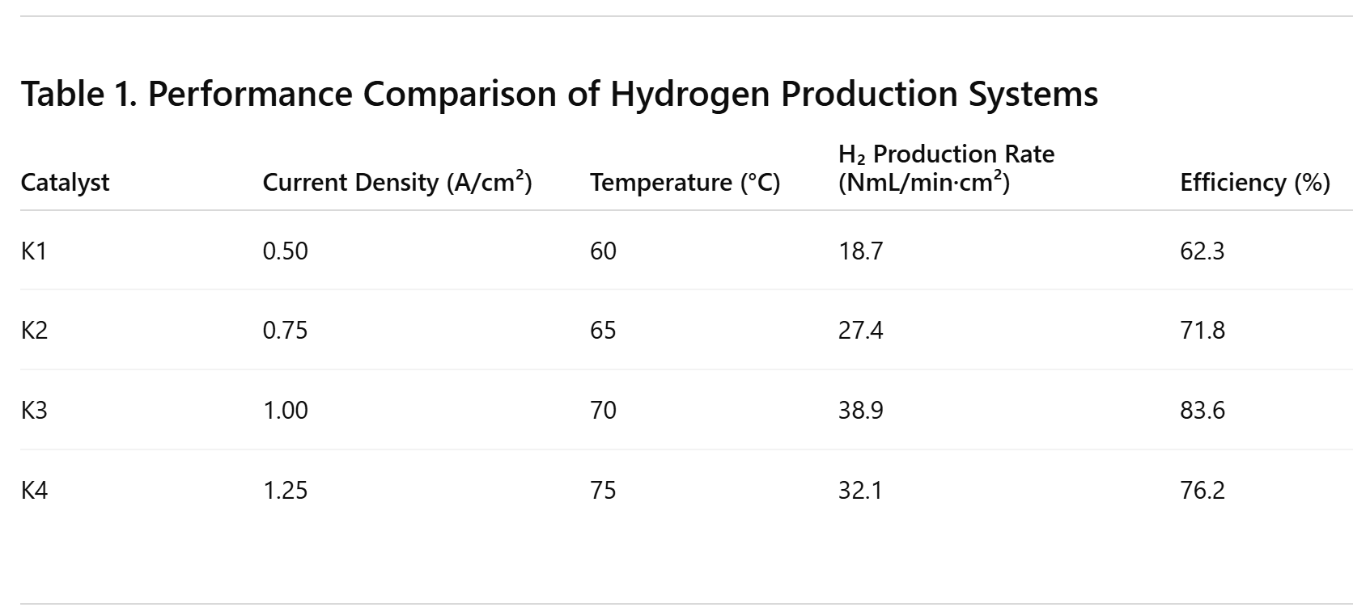
- References
Use a consistent citation style (IEEE recommended)
References should be relevant and limited (avoid excessive listing)
Cite sources in the text using numbered brackets: [1], [2], [3]

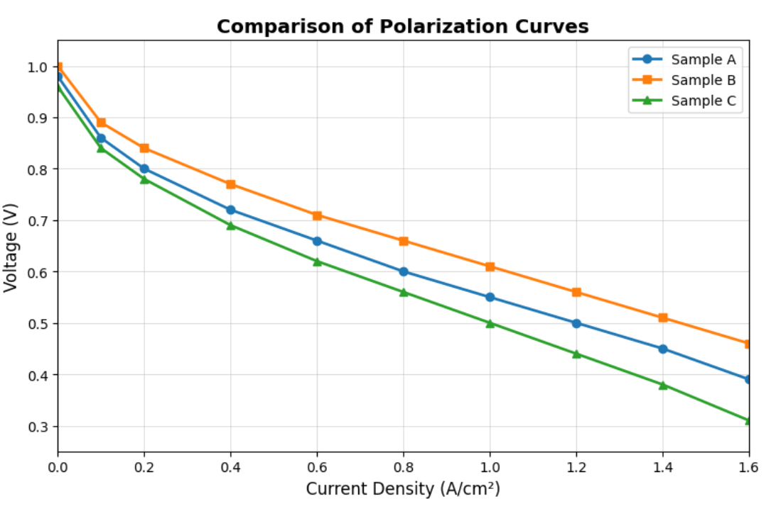
Fig. 1 A sample line graph using colours which contrast well both on screen and on a printed page

- Evaluation Criteria

Submissions will be evaluated based on:
- Technical quality and correctness
- Originality and contribution
- Relevance to hydrogen technologies
- Clarity of presentation
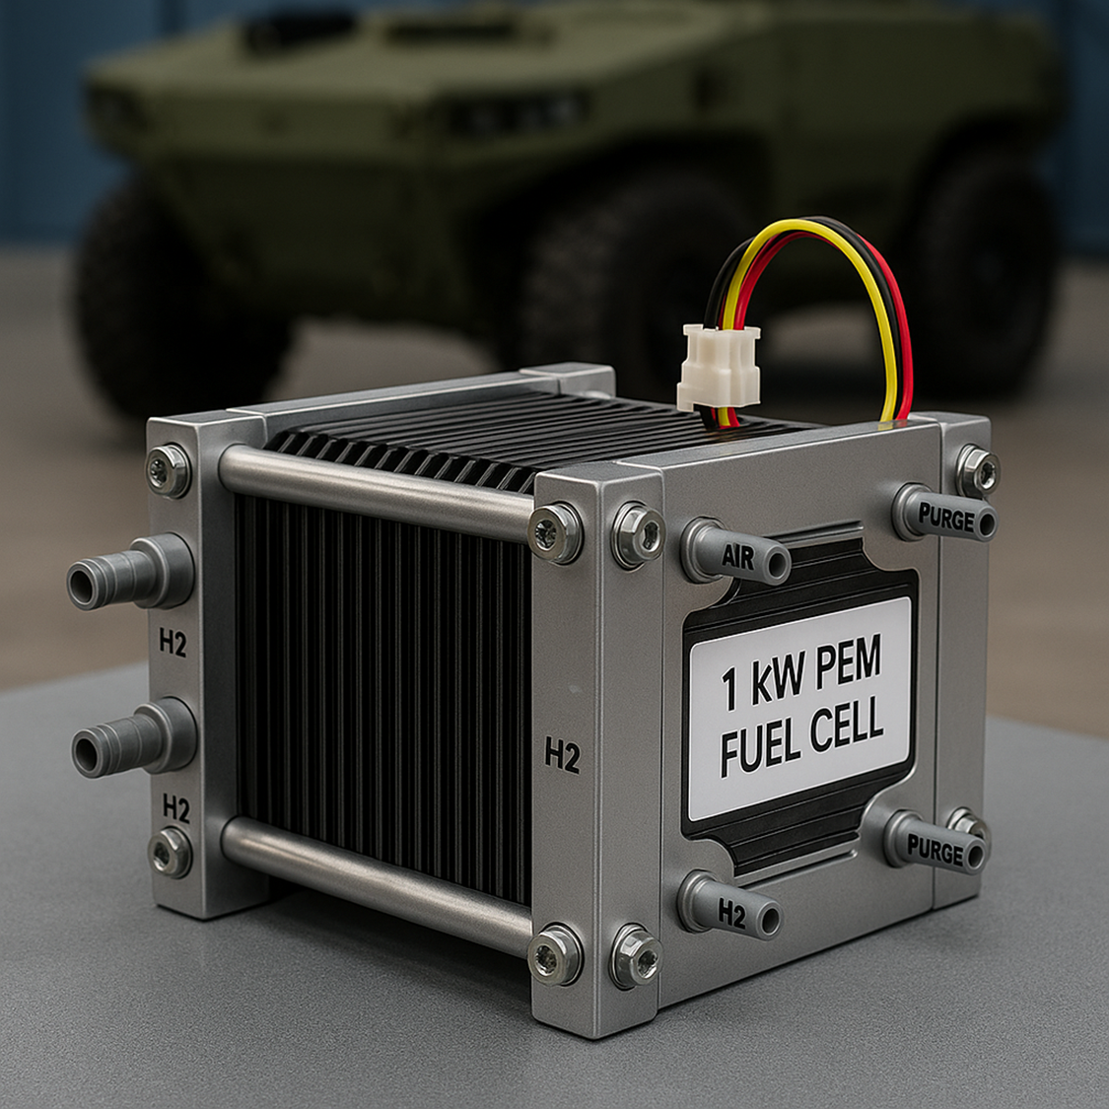
Fig. 2 Example of an image with acceptable resolution

- Important Notes
The work must be original and unpublished
At least one author must attend the summit
Selected contributions may be invited for journal publication after peer review
- Publication Opportunity

Selected papers will be invited for submission to special issues of:
- International Journal of Hydrogen Energy (SCI) (planned)
- Energy Studies (TR Dizin)
- International Journal of Energy Horizon
All submissions will undergo the respective journal’s peer-review process.
- Conclusions
This template is designed to ensure consistency and clarity in submissions while maintaining a balance between academic rigor and practical relevance aligned with the objectives of the Türkiye Hydrogen Summit.
Acknowledgment
The heading of the Acknowledgment section and the References section must not be numbered.
References
- S. M. Metev and V. P. Veiko, Laser Assisted Microtechnology, 2nd ed., R. M. Osgood, Jr., Ed. Berlin, Germany: Springer-Verlag, 1998.
- J. Breckling, Ed., The Analysis of Directional Time Series: Applications to Wind Speed and Direction, ser. Lecture Notes in Statistics. Berlin, Germany: Springer, 1989, vol. 61.

